Table of Contents

Install SBT 2

Install Scala plugin for eclipse 12

Integrate sbt with Scala IDE for Eclipse 14

First create project in Eclipse and then integrate with sbt 15

Use sbt to generate eclipse project 21

First Install java and scala on your machine

# Install SBT

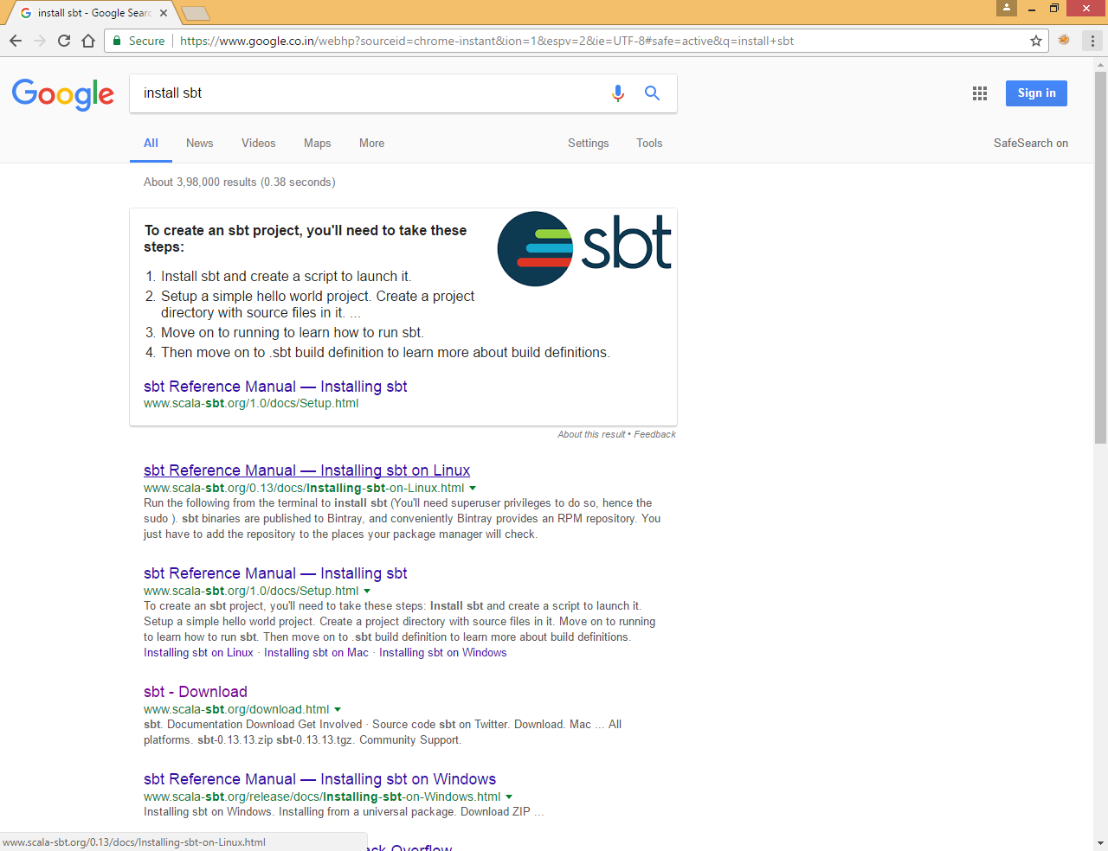

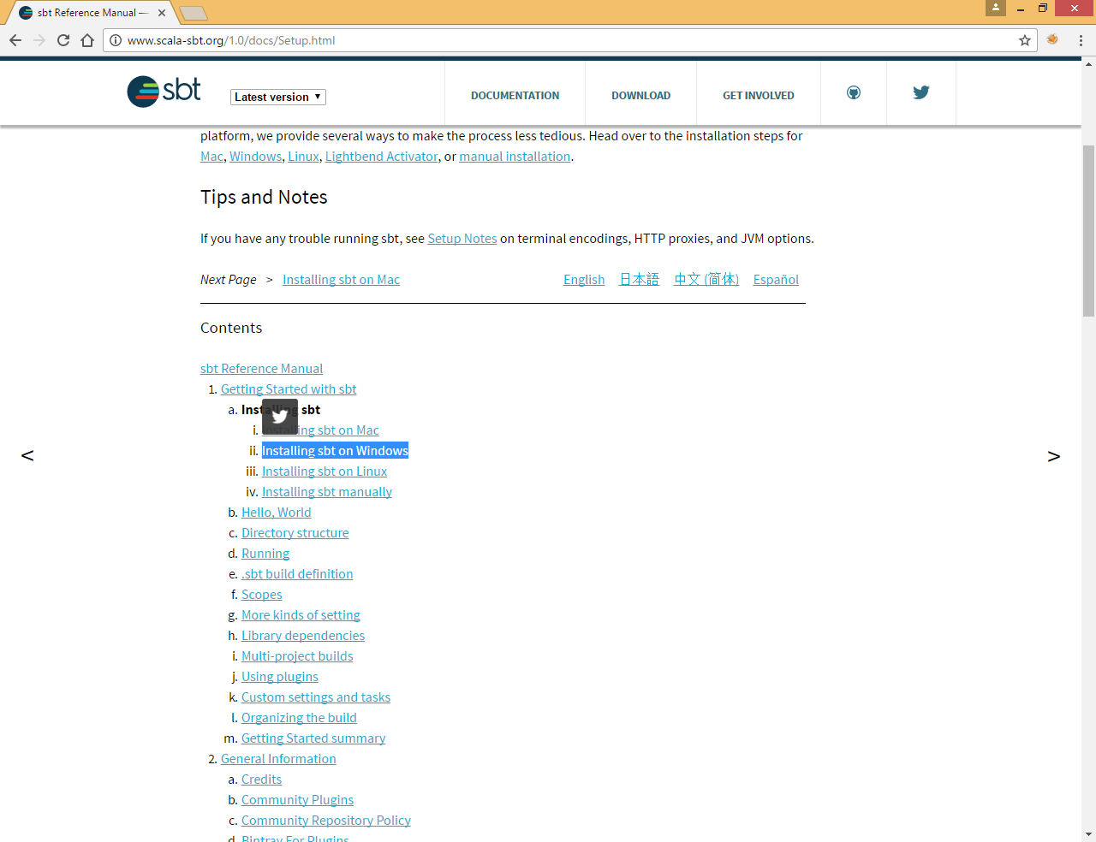

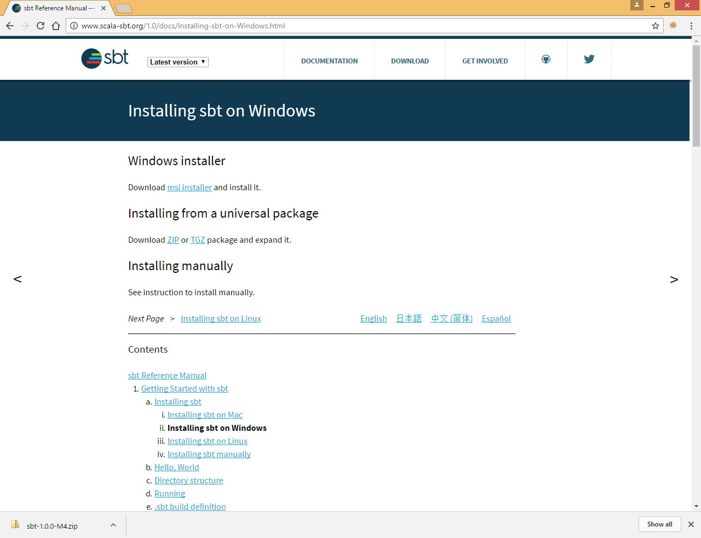

Go to Download tab

Download msi installer

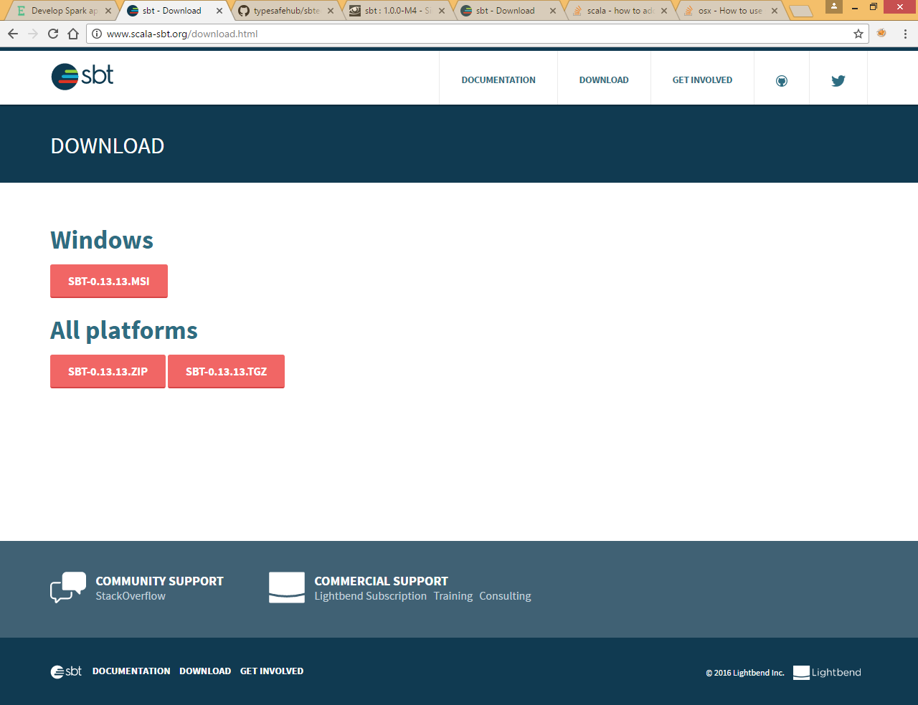

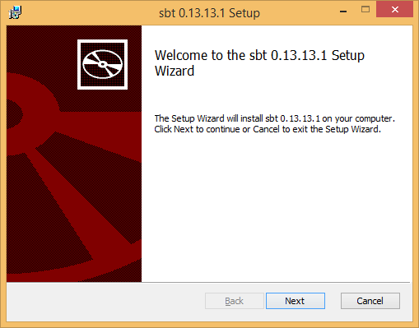

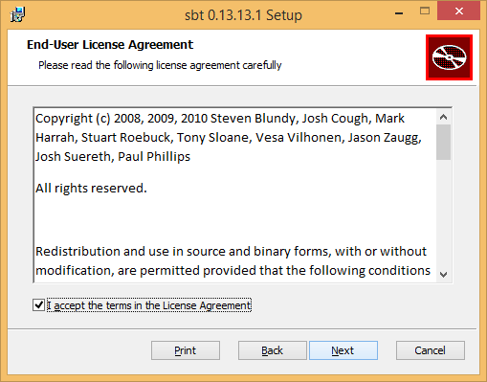

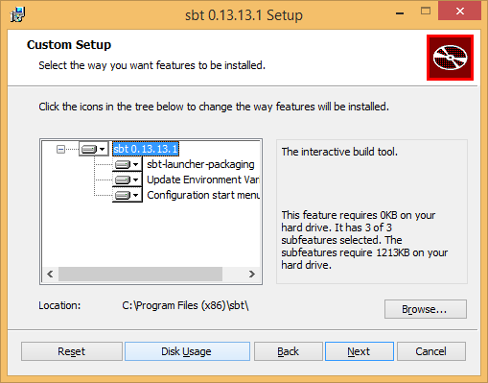

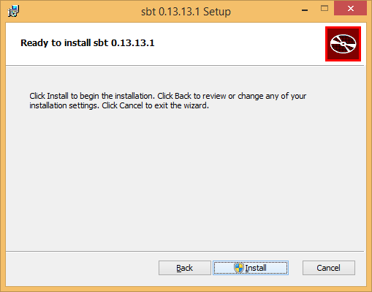

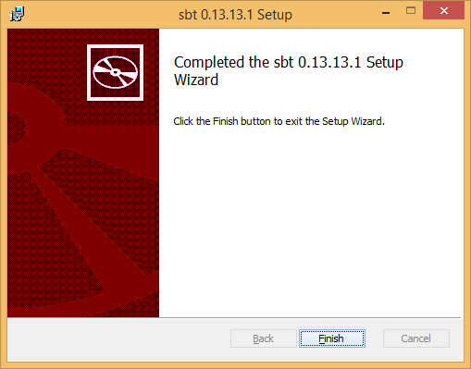

Go to your project directory and run sbt command

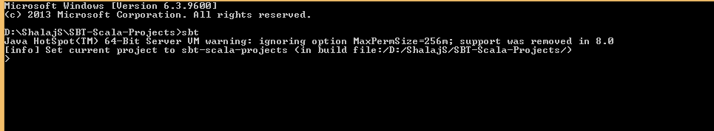

You will see target folder under directory

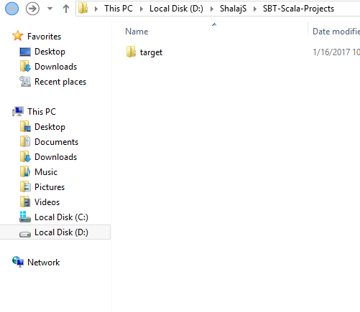

Now create src/main/scala directory

And create hw.scala object under this directory

Here we are using argument and if argument is not passed we are just printing hello world

|  |
| --- |
| object hw{    def main(args: Array[String]): Unit = {  try {  println("hello "+args(0))  } catch {  case ex : ArrayIndexOutOfBoundsException => println( " Hello World")  }    }  } |

Check scala version



Create build.sbt file under Scala-Sbt-Project using

|  |
| --- |
| name := "hw"  version := "1.0"  scalaVersion := "2.11.4" |



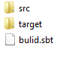

Now run sbt package command to build the classes and jar file

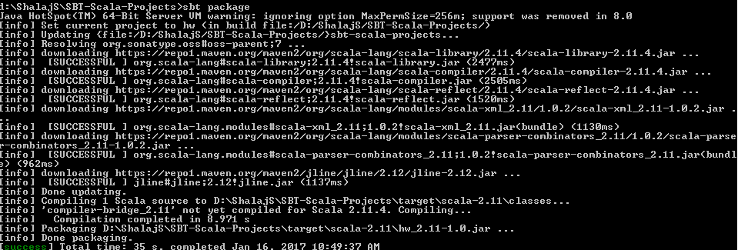

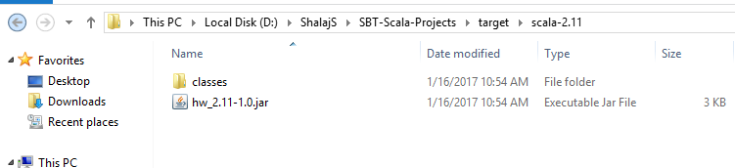

To run application

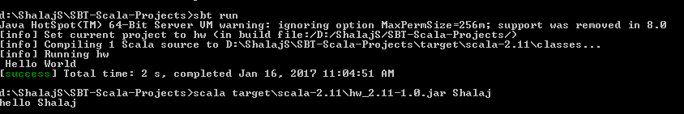

You can use sbt run directly to run the application, it will execute the program using build.sbt file and run the application accordingly

If you want to pass some argument in this case you need to use scala command

#scala <jar file path> < argument list>

Or we can use

#sbt “run-main <classname> <argumentlist>”

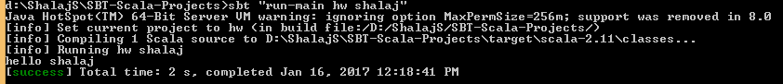

# Install Scala plugin for eclipse

* Launch Eclipse
* Go to "Help" in top menu -> "Eclipse Marketplace"
* Search for Scala IDE
* Click on Install
* Once installed restart Eclipse

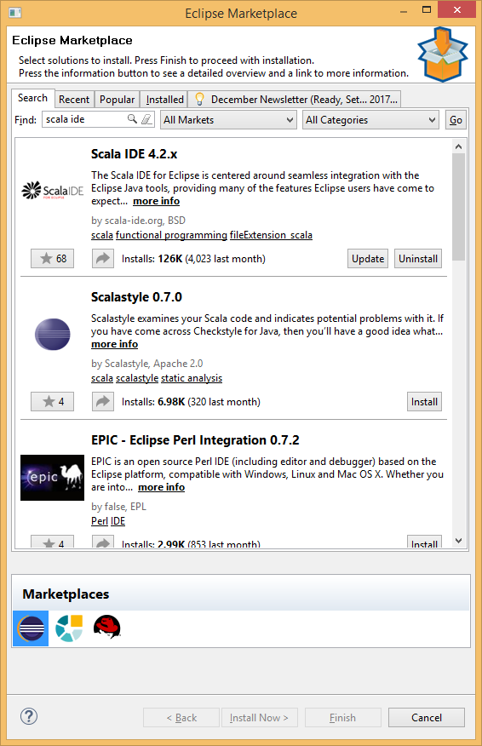

Choose Scala IDE and install it (I already installed scala ide as you can see update and uninstall button)

# Integrate sbt with Scala IDE for Eclipse

Now we will see how sbt can be integrated with Scala IDE for Eclipse

Steps to integrate sbt with Scala IDE for Eclipse

* Check whether <home dircectory>/.sbt/<version>/plugins/plugins.sbt exists, if not
* Create plugins directory under ~/.sbt/<version> mkdir -p ~/.sbt/0.13/plugins

In windows go to path C:\Users\shalajs\.sbt\0.13\staging and create plugins directory

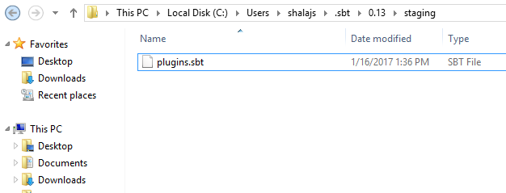

* cd ~/.sbt/0.13/plugins
* Create plugins.sbt file and add following contents

|  |
| --- |
| addSbtPlugin("com.typesafe.sbteclipse" % "sbteclipse-plugin" % "2.5.0") |

Here we define group id artifact id and version

Here we are directing SBT to use eclipse

Advantages of integrating sbt with eclipse

* Ability to generate eclipse projects
* Build deployable jar file
* Works well with scala

There are 2 ways to create jar file with sbt and Scala IDE for scala

## First create project in Eclipse and then integrate with sbt

* + Go to project directory
  + Go to java build path

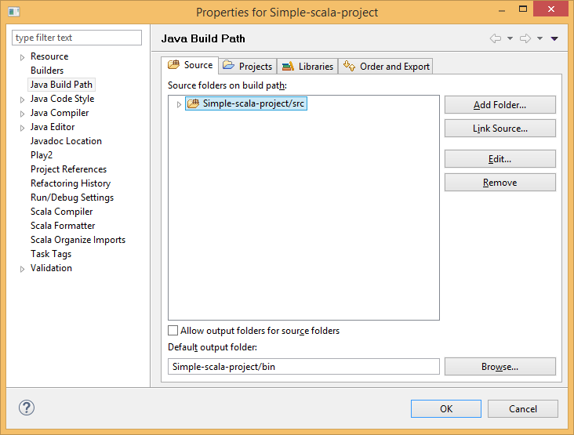Add folder

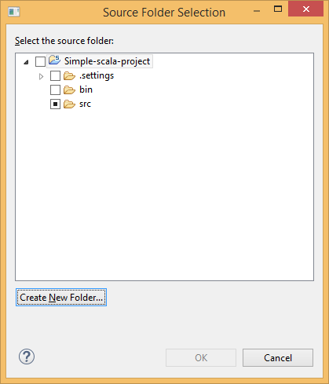

Click Crete New Folder

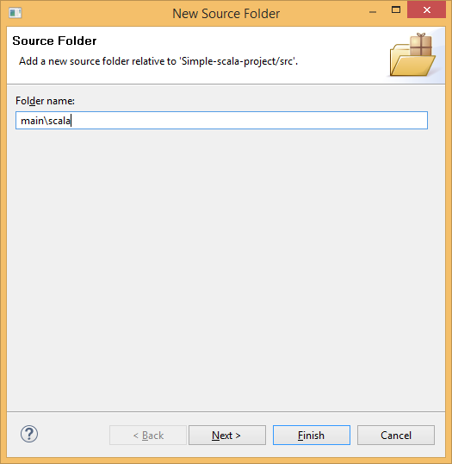

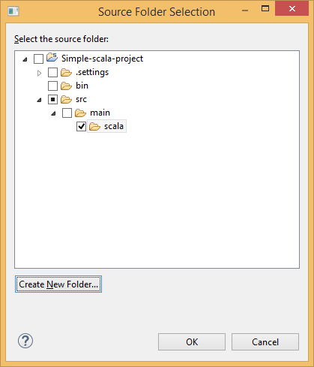

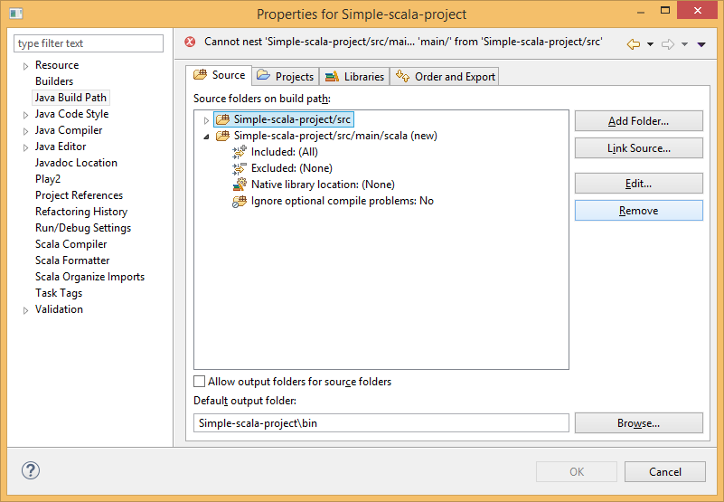

Remove old src folder

Create scala object under src/main/scala folder

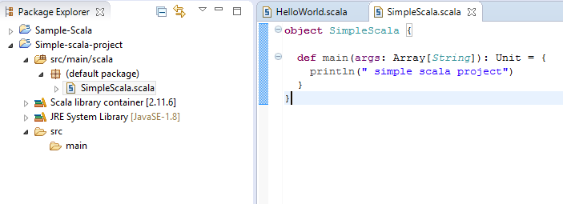

* + Create build.sbt and add name, version and scalaVersion

|  |
| --- |
| name := "sample-sbt"  version := "1.0"  scalaVersion := "2.11.4" |

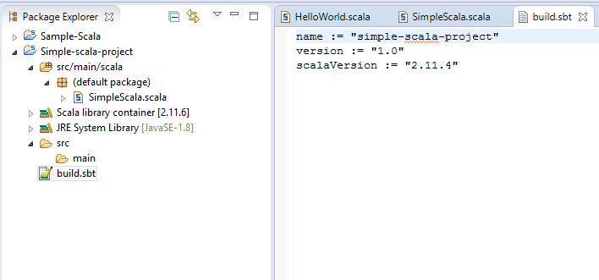

* + Run sbt package

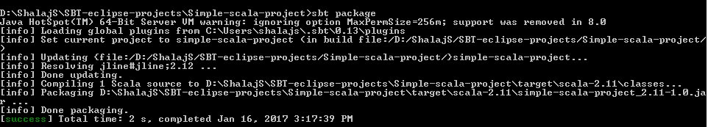

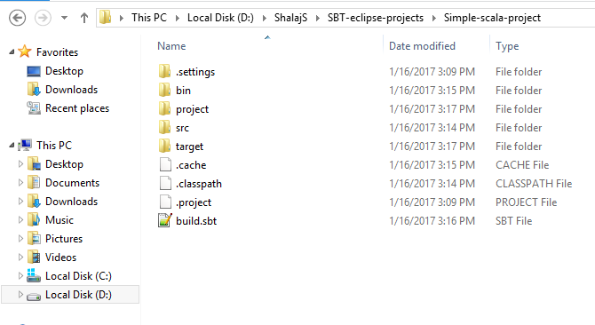

* + Now jar file will be created

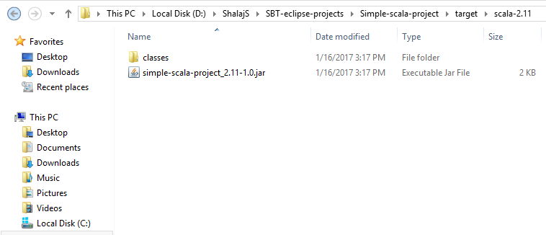

* + Now run the file

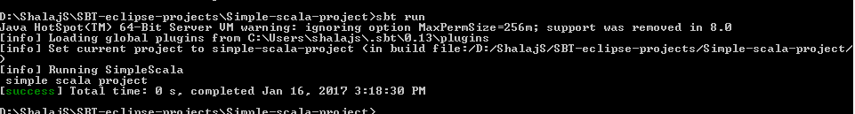

## Use sbt to generate eclipse project

* + Go to working directory and create directory for project
  + Run mkdir -p /src/main/scala or create folder structure in windows
  + Create build.sbt under project directory

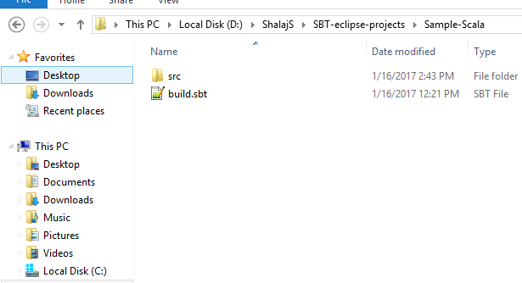

|  |
| --- |
| name := "sample-sbt"  version := "1.0"  scalaVersion := "2.11.4" |

* + Run sbt eclipse

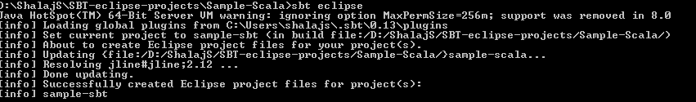

* + Now project layout is ready

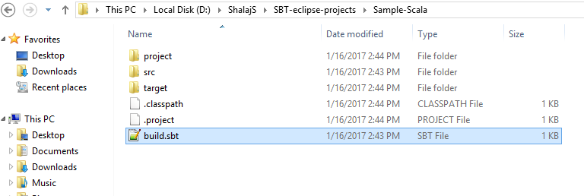

* + Use Scala for IDE to import the project

File >> Import

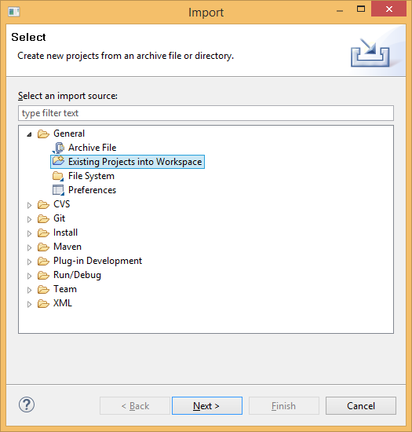

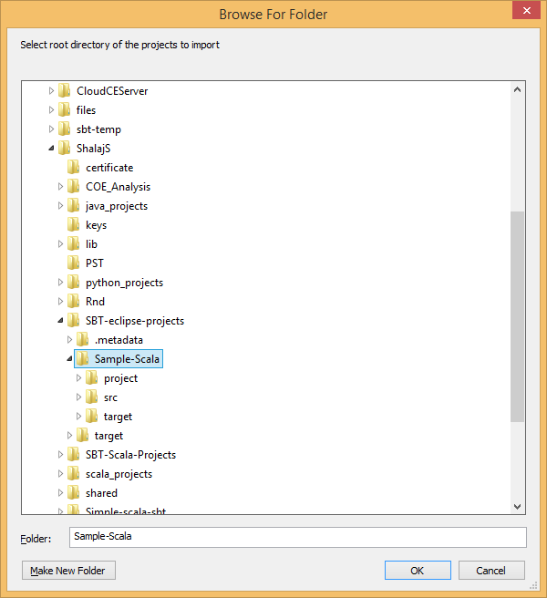

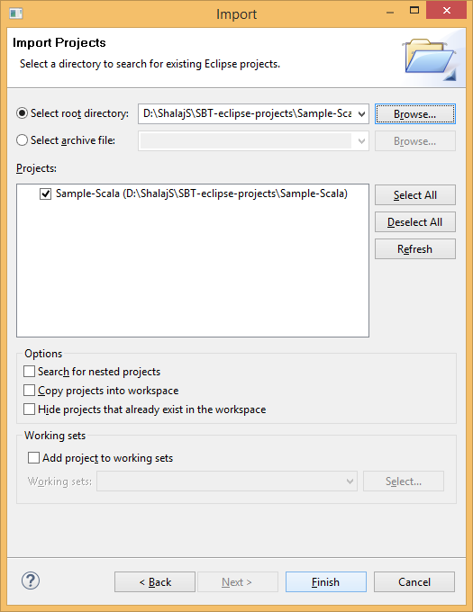

* + Create code using Scala for IDE

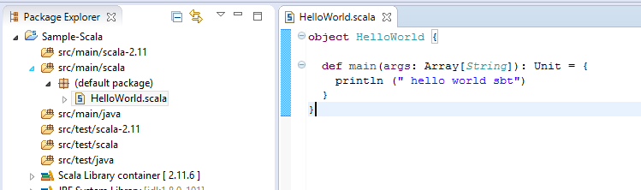

* + Test it and build it using sbt package

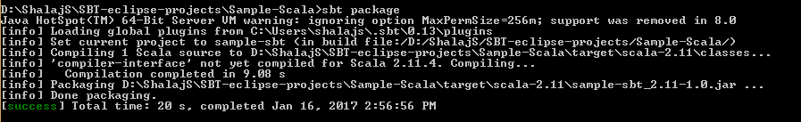

* + Now jar file will be created

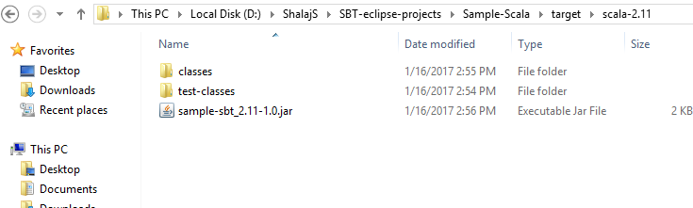

* + Now run the program

